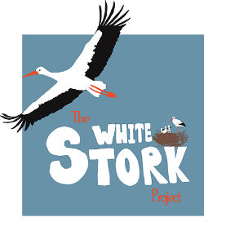
The White Stork Project
Learn about the beautiful white storks by filling in as much of this sheet as you can!
Key words:
Can you match these key terms with the correct word below?
Ecosystem, Prey, Adaptation, Migration, Population, Habitat, Pollution, Predator, Incubation
Special features that an organism has, to help it survive in its environment.
The place where an organism lives.
The introduction to harmful materials into an environment.
The seasonal movement of animals from one area to another.
The process birds and some other animals use to maintain the right heat and humidity to hatch an egg
A biological community of organisms interacting with their environment.
The number of individuals of a particular species living in an area.
An animal that hunts and eats other animals.
An animal that is hunted. Some animals are both predator and prey.

Who eats who?
Storks eat a wide range of prey items and play a role in natural ecosystems.
Can you complete the food web below by drawing arows pointing from producer or prey to consumer? A couple are done for you!
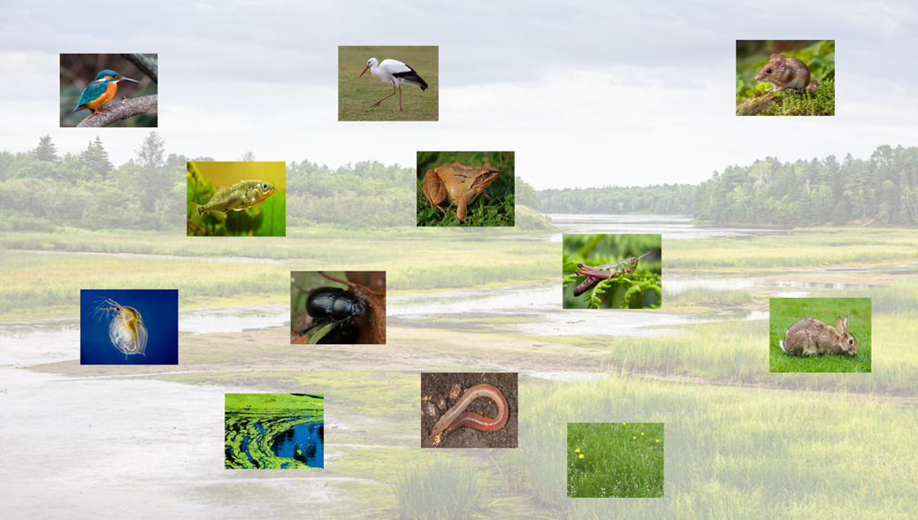

Question to consider – why do you think storks like to live in wetland areas?
Stork Adaptations
Large, sharp beak
The sharp beak (up to 30 cm long) is adapted for collecting a variety of prey, including small insects. They will ‘clatter’ their beak to greet their partner and it can also be used in defence!

Long legs
Storks often forage for food in wetland and grassy areas. Having long legs allows them to move easily through undergrowth and see above plants to locate prey.

Wide feet
The large feet and strong claws of a stork help it to land in trees. They have a large surface area so the stork can move on wet ground easily without sinking.

Fantastic eyesight
Storks have brilliant vision. They have to be able to see tiny insects that make up their food, but also be able to navigate from up to 5km above the surface of the Earth.

Good sense of smell
Birds can have a surprisingly good sense of smell. There are records of storks being able to detect the smell of cut grass (where they can find a lot of insects to eat) from over 20km away!

Powerful, large wings
The wingspan of a stork can be up to 2m. They are fantastic at using these wings to glide on air thermals to help them conserve energy, allowing them to make journeys of thousands of kilometres.

How are storks specially adapted to survive in their habitat? Can you fill in the boxes?
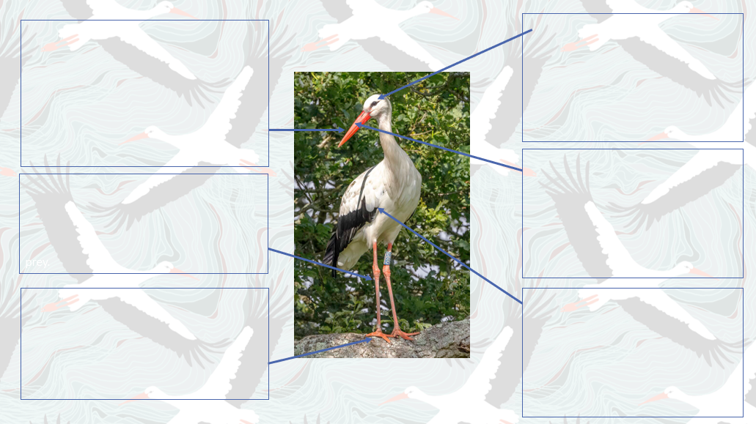

If you have any questions on white storks, get in touch with us through our website: https://www.whitestorkproject.org/ or follow us on social media for all the latest news (search white stork project on Instagram or Facebook).

